Cairo University  
Faculty of Computers and Information



**CS251**

**Software Engineering I**

Project Name

Software Design

**Mohamed Alaa Aldin Elkilany**

**Mohamed shabaan mohamed**

**Mahmoud wagdy saeed**

Month & Year

Contents

Instructions [To be removed] 3

Team 3

Document Purpose and Audience 3

System Models 3

I. System Decomposition 3

II. Class diagrams 6

Important Algorithm 7

III. Sequence diagrams 7

Class - Sequence Usage Table 9

Ownership Report 10

Policy Regarding Plagiarism: 10

References 10

Authors 10

# Team

|  |  |  |  |
| --- | --- | --- | --- |
| **ID** | **Name** | **Email** | **Mobile** |
| 20170245 | Mohamed Alaa Aldin Elkilany | [Medoa3844@gmail.com](mailto:Medoa3844@gmail.com)  [Mohamed.a@stud.fci-cu.edu.eg](mailto:Mohamed.a@stud.fci-cu.edu.eg) | 01154515208 |
| 20170236 | Mohamed shabaan mohamed | m.shapaan959@gmail.com | 01029230429 |
| 20170273 | Mahmoud wagdy saeed | Wagdy1774@gmail.com | 01279859060 |

# Document Purpose and Audience

* The introduction of the Software Requirements Specification (SRS) provides an overview of the entire SRS with purpose, scope, function Requirements, Nonfunction Requirements and overview of the SRS. The aim of this document analyzes and give an in-depth insight of the complete **API** by defining the problem statement in detail
* **the audience to read this document** **client, project manager, system analysis and system designer**

# System Models

## I. System Decomposition

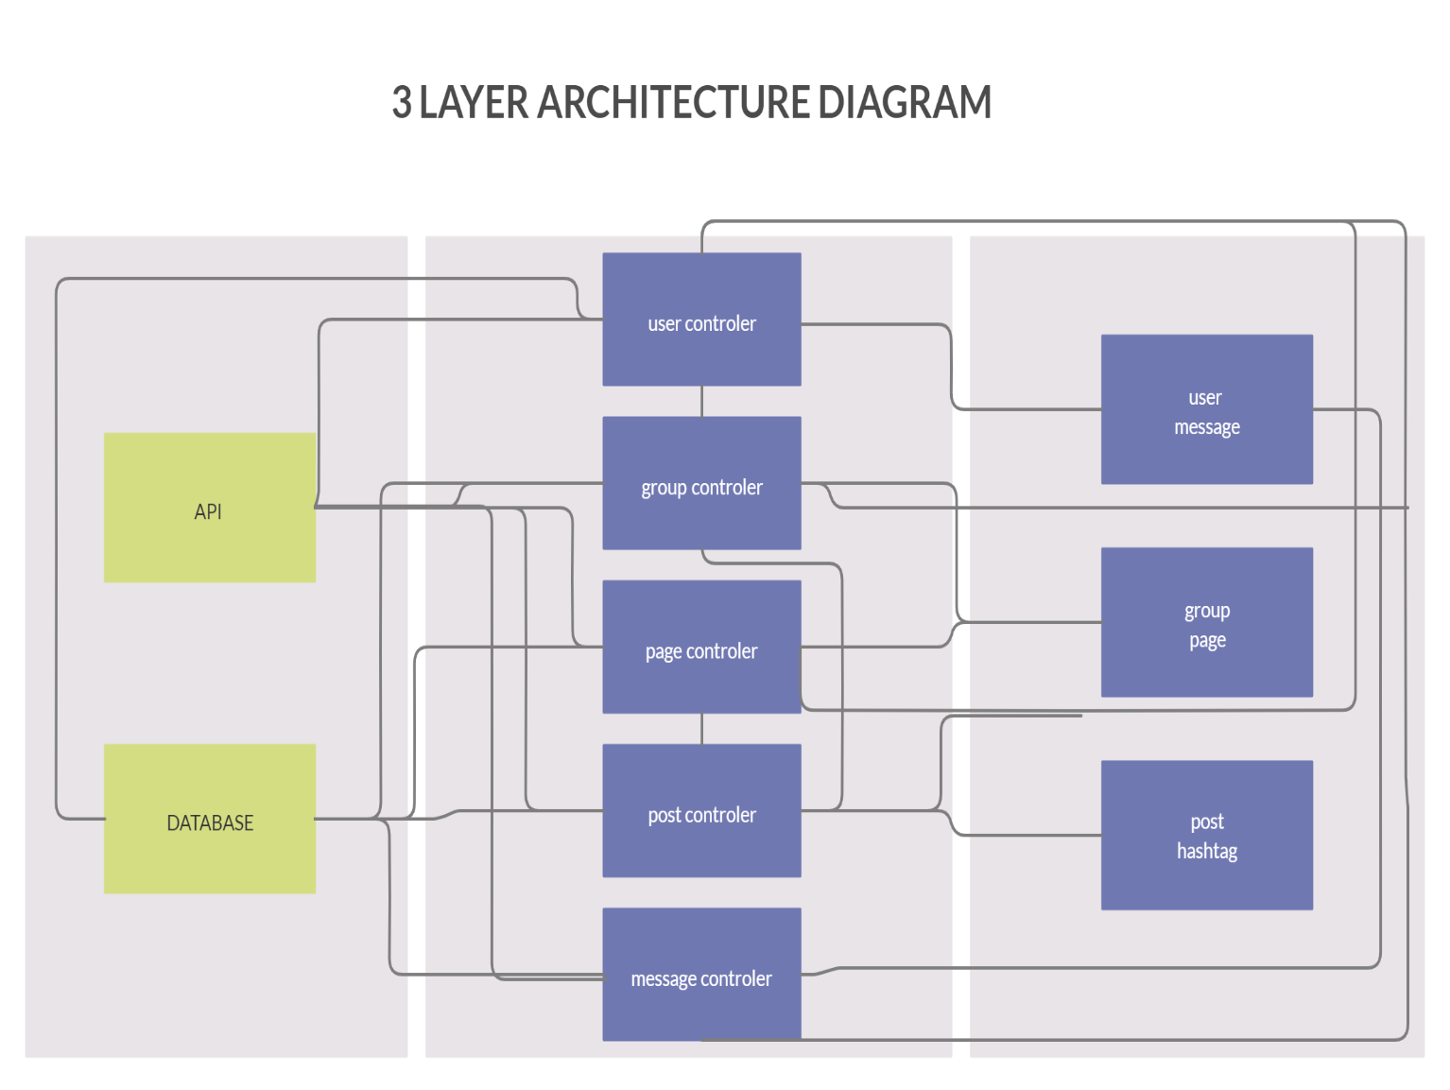

## II. Class diagrams

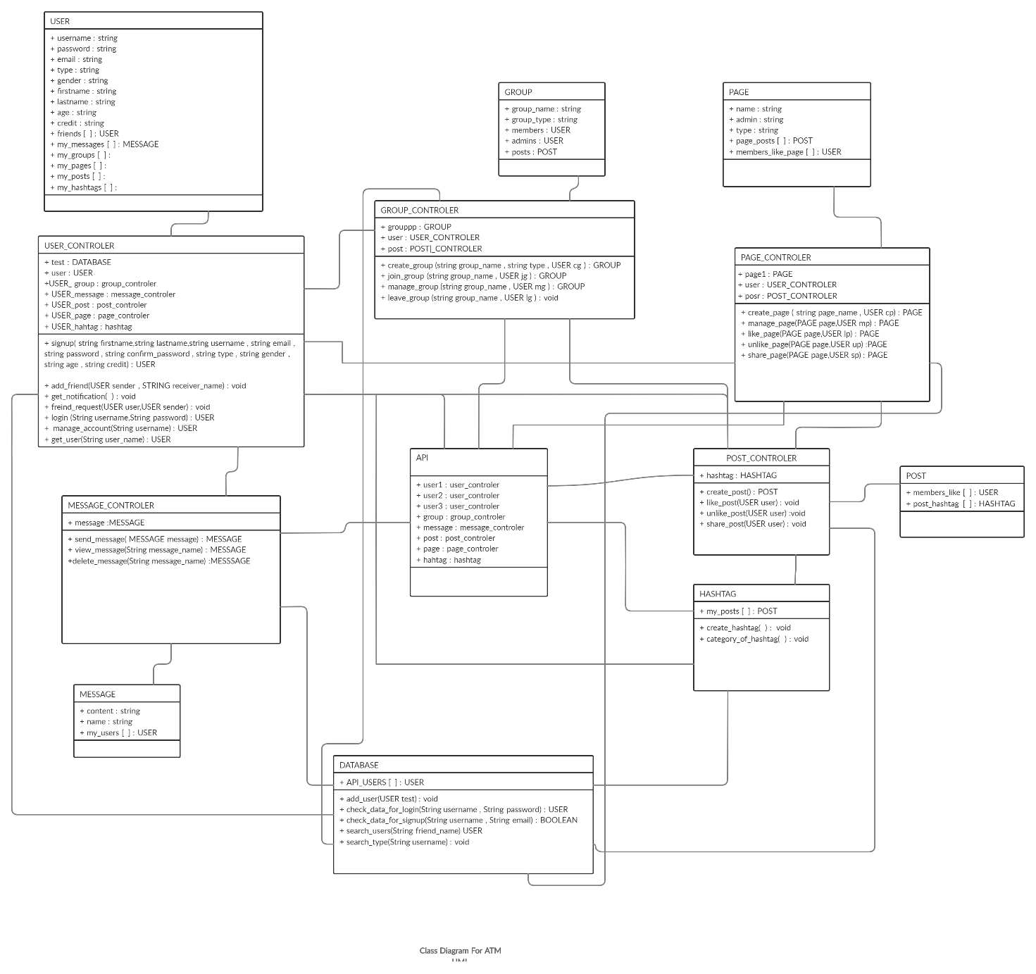

| **Class ID** | **Class Name** | **Subsystem ID** | **Description & Responsibility** |
| --- | --- | --- | --- |
| 1 | API | 1 | The main component |
| 2 | Database | 2 | The component that store the data |
| 3 | User_controler | 3 | Have all the user functions |
| 4 | Group_controler | 4 | Have all the group functions |
| 5 | Page_controler | 5 | Have the page functions |
| 6 | Message_controler | 6 | Have the message functions |
| 7 | Post_controler | 7 | Have the post functions |
| 8 | User | 8 | The model of user that have all the user data |
| 9 | Group | 9 | The model of group that have all the group data |
| 10 | Page | 9 | The model of page that have all the page data |
| 11 | Post | 10 | The model of post that have all the post data |
| 12 | Message | 8 | The model of message that have all the message data |
| 13 | hashtag | 10 | Have all the data and functions of hashtag |

## 

## III. Sequence diagrams

1-Signup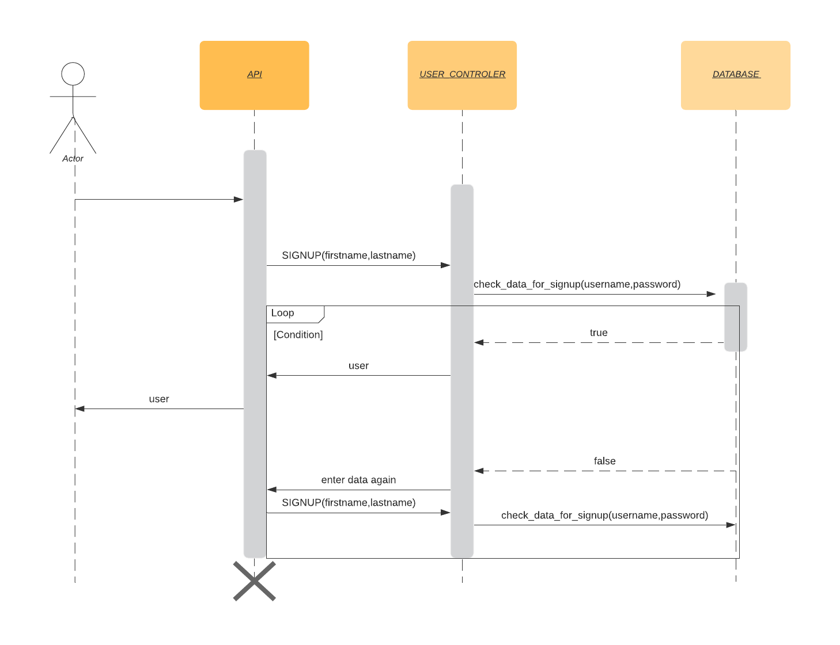

2-Add friend

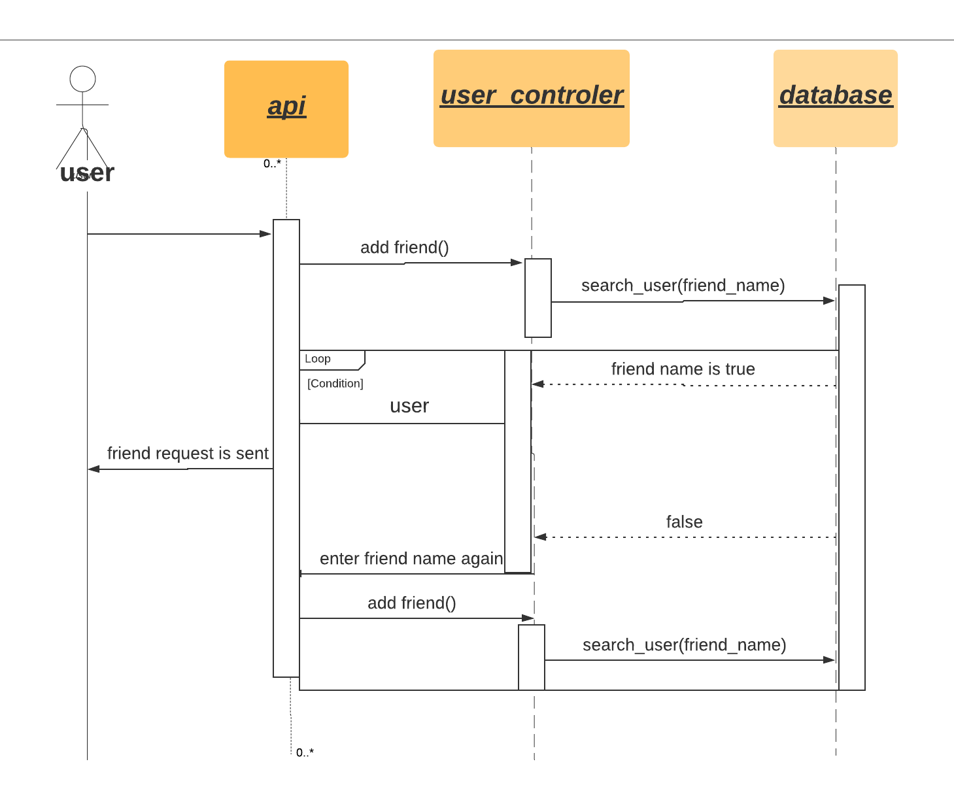

3-Unlike page

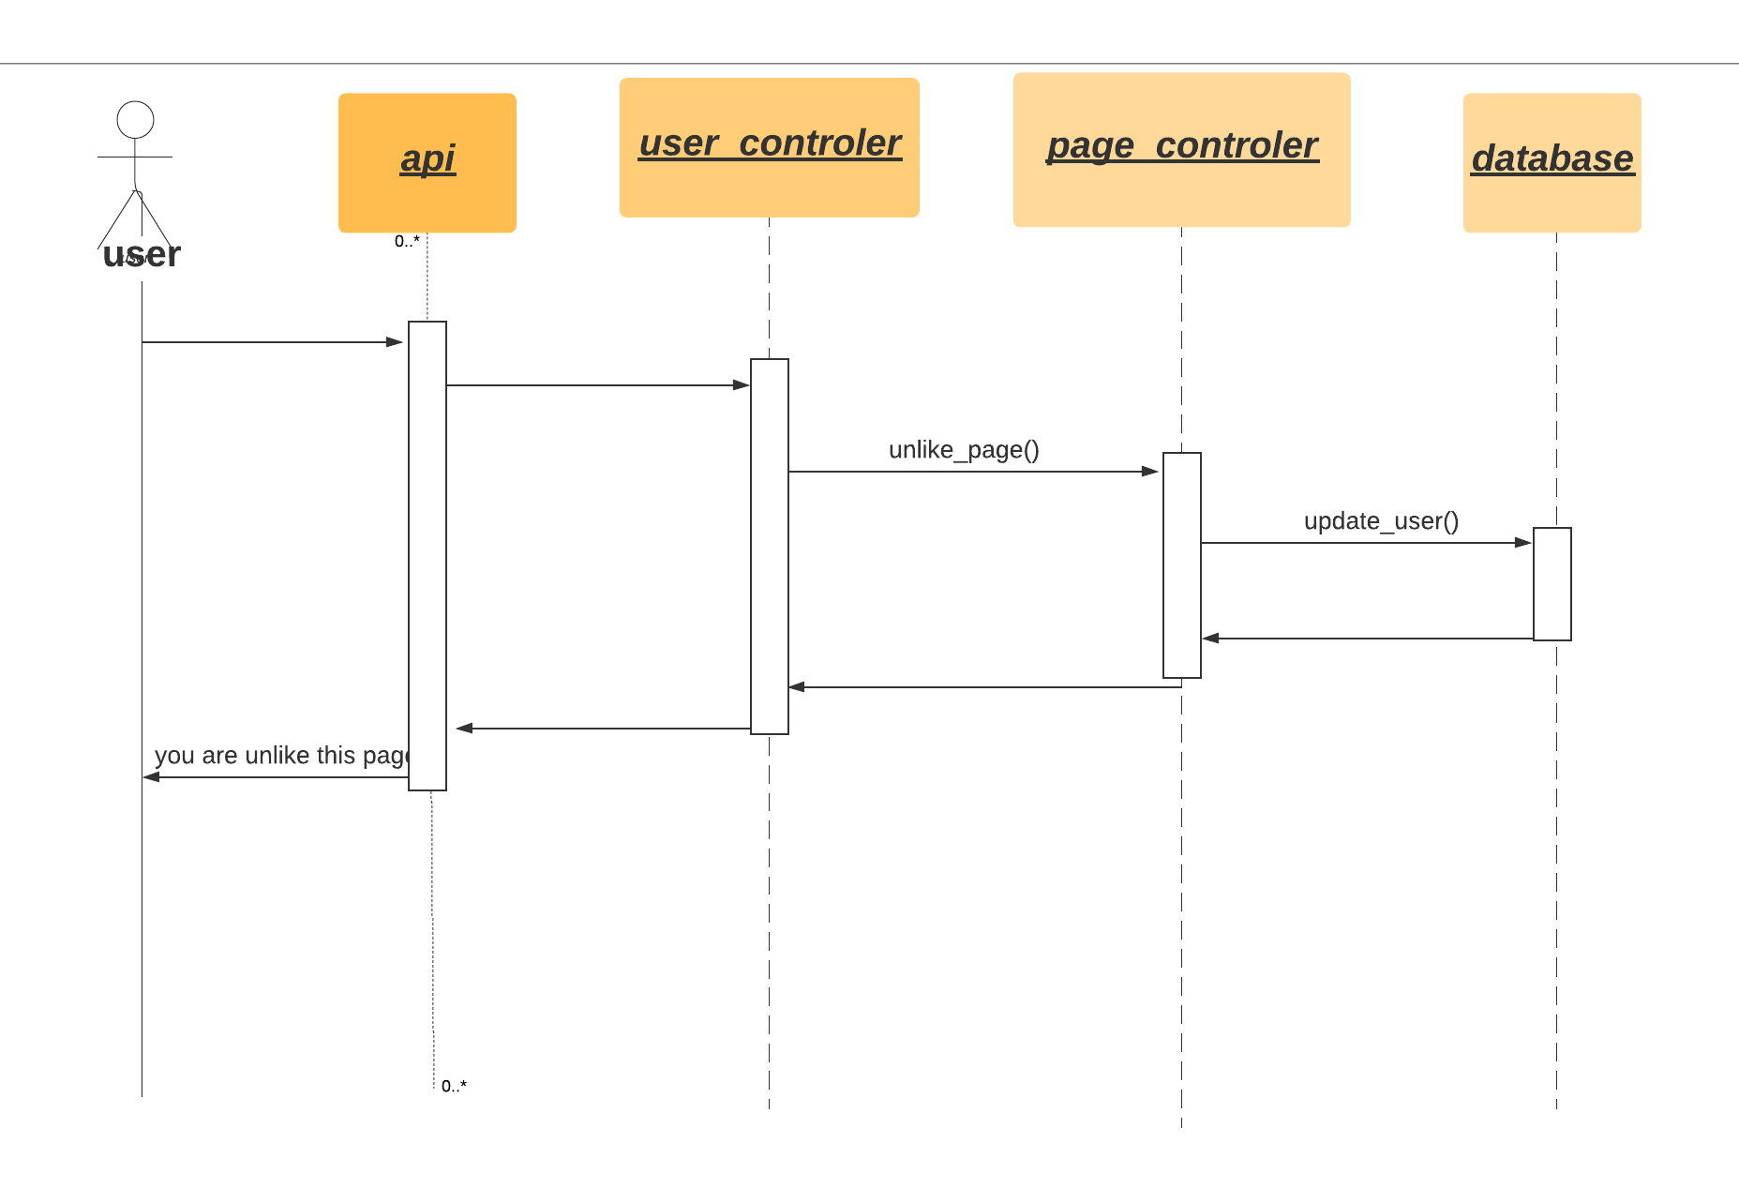

4-Leave group

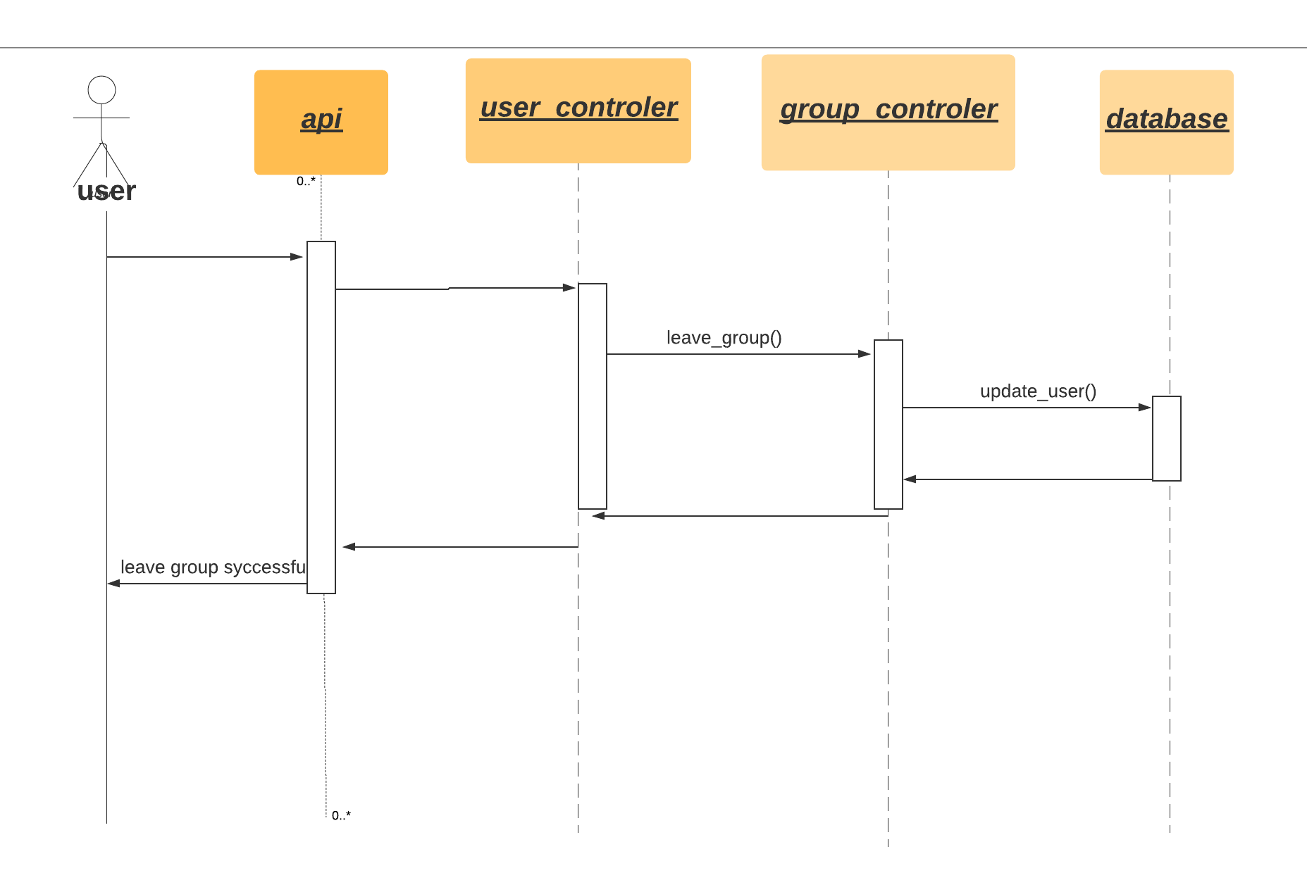

5-Send message

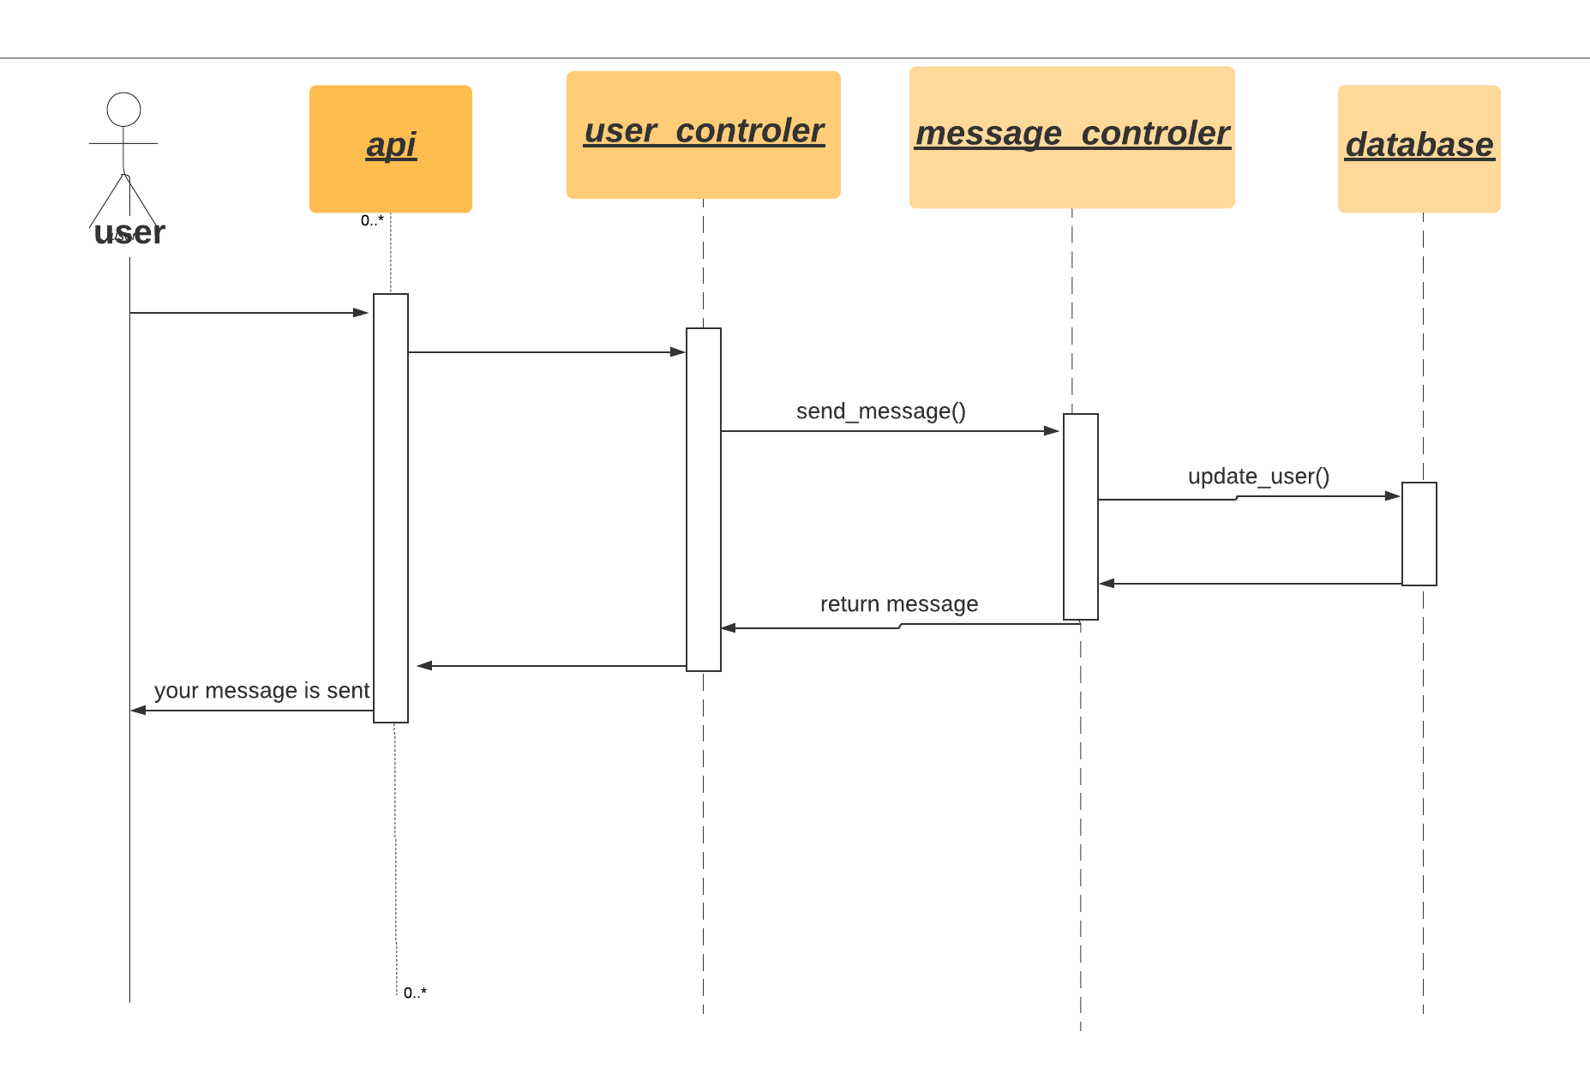

6-Like post

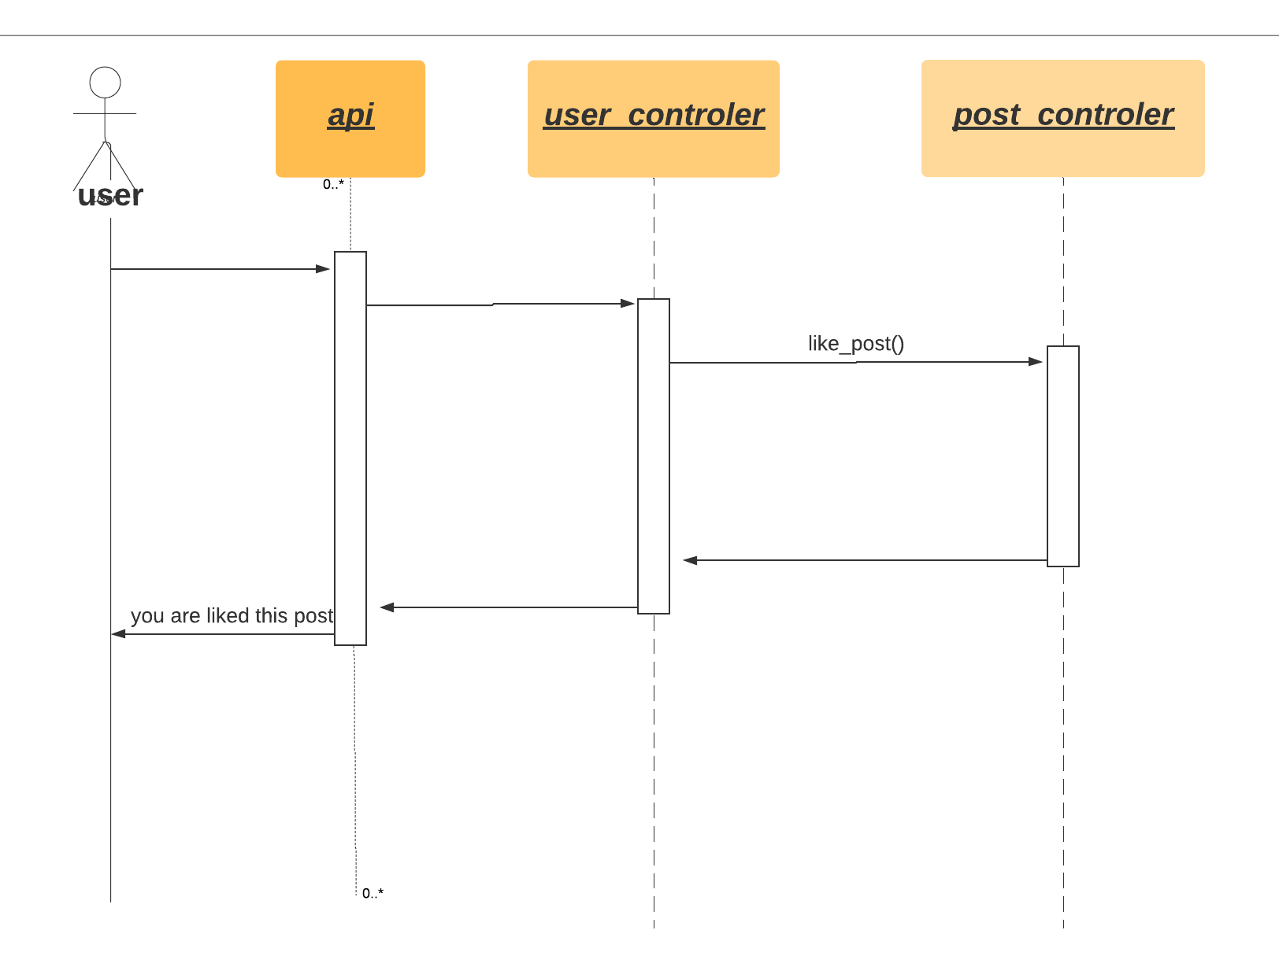

### Class - Sequence Usage Table

| **Class Name** | **Sequence Diagrams** | **Overall used methods** |
| --- | --- | --- |
| USER_CONTROLER | 1,2 | Signup, add_friend |
| GROUP_CONTROLER | 5 | Leave_group |
| POST_CONTROLER | 6 | Like_post |
| MESSAGE_CONTROLER | 4 | Send_message |
| PAGE_CONTROLER | 3 | Unlike_page |

# Ownership Report

|  |  |
| --- | --- |
| **Item** | **Owners** |
| Sequence diagram _ leave group & send message | Mohamed Alaa |
| Sequence diagram _ sign up & addfrind | Mahmoud Wagdy |
| Sequence diagram _ unlike page& like post | Mohamed Shaban |
| System decomposition | Mohamed Alaa |
| Class diagram | Mahmoud Wagdy & Mohamed Shaban |
| Tresability matrix |  |
| Implementation | Mahmoud Wagdy & Mohamed Shaban, Mohamed Alaa |
| Testing | Mahmoud Wagdy & Mohamed Shaban, Mohamed Alaa |

# 

# Test cases

User1 signup to the system

User2 signup to the system

User3 signup to the system

User1 send friend request to user2

User1 send friend request to user 3

User2 accept the friend request

User3 accept the friend request

# References

* <https://www.smartdraw.com/component-diagram/>
* <https://www.tutorialspoint.com/uml/uml_component_diagram.htm>

# Authors

* Mohamed Alaa, Mahmoud Wagdy and Mohamed Shaban